

**BIM423 – SOFTWARE ENGINEERING**

**2022-2023 FALL SEMESTER**

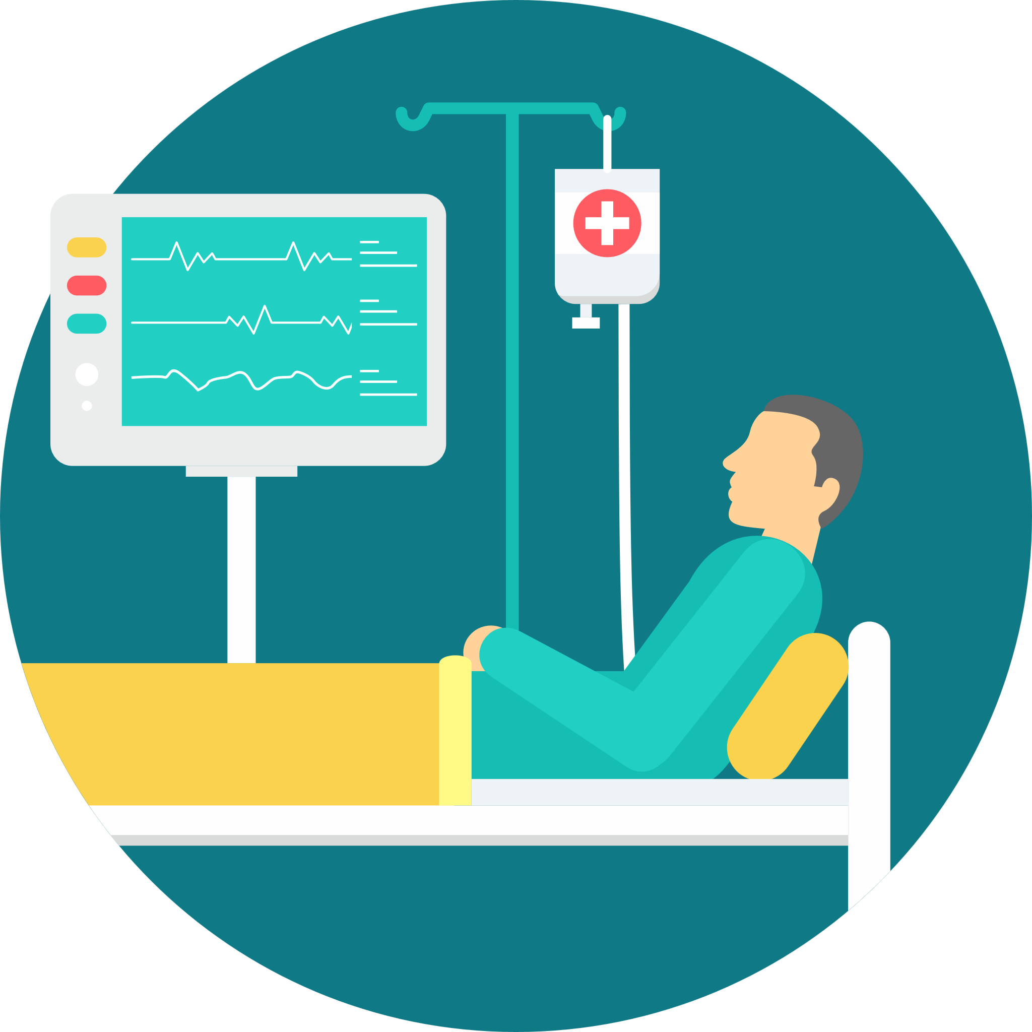

**Virtual Patent**

**Group 12**

**Week 4 / 24.10.2022 – 30.10.2022**

# Members

1. ***Uğur Dindar***
2. ***Emre Kayacık***
3. ***İdris Can Bölükbaşı***
4. ***Oğuzhan Çetin***
5. ***Umutcan Yavuz***
6. ***Yunus Emre Korkmaz***

# Links

* ***GitHub Link: https://github.com/VPatient***
* ***Website Link: https://vpatient.github.io/***
* ***Repo Link: https://github.com/orgs/VPatient/repositories***

# Works Done

* API of the project has been initialized. CI/CD to the server of our team has been established. MongoDB cloud server has been configured.

Our back-end team are going to use Node.js and Express libraries to build a robust API. Thus, we have initialized our API and committed it to the master of VPatientAPI repository. We’ve decided that we are going to need a CI/CD pipeline to build our project in a proper way. In order to build a CI/CD and host our API in a server, we initialized a GitHub runner on the server.

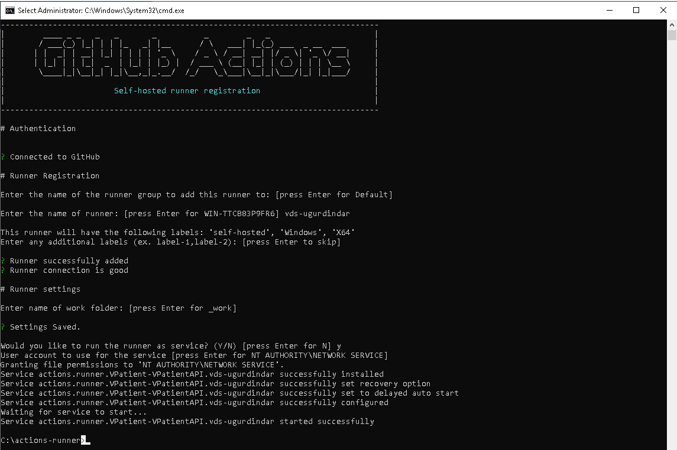

Runner (server) appeared in runners section of GitHub actions after registration of the runner.

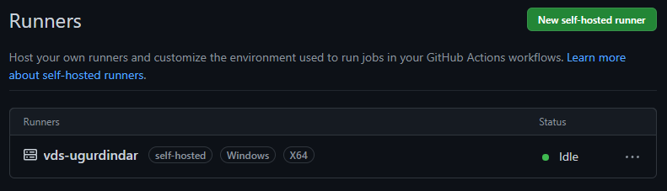

Then we have created a GitHub action to build our Node.js project whenever a pull request completes or a commit merge to the master. From that point the rest is handled by runner.



Everyone that works in our project can easily reach and send requests to always updated version of our API easily all thanks to CI/CD.

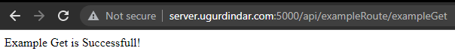

* Our mobile development team had set application distribution function of Firebase and maintained CI/CD pipeline of virtual patient mobile application.

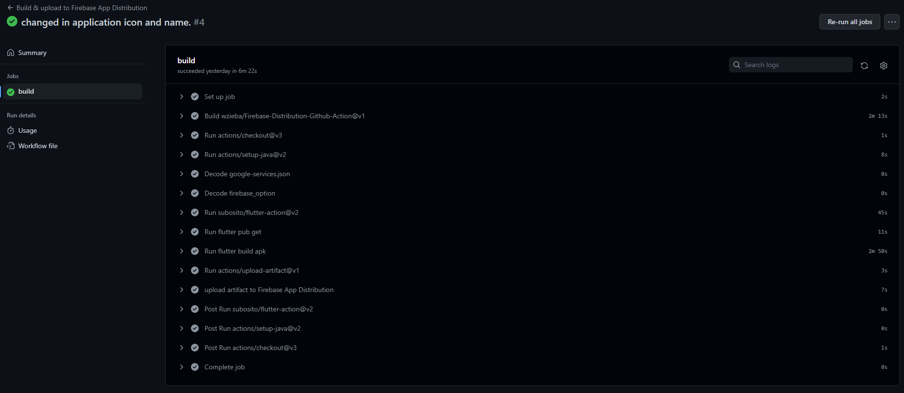

* Front-end development team also maintained a React – GraphQL project structure which is going to be used in our VPatientDashboard project.

# Task Distribution

* ***Emre Kayacık: Initialization of the API. Configuring***
* ***Uğur Dindar: Establishing a CI/CD pipeline to the API. Configuring DB on the server.***
* ***İdris Can Bölükbaşı: Setting up application distribution function of Firebase and also maintaining a CI/CD pipeline of virtual patient mobile application. Started to design and implement login screen using Firebase.***
* ***Oğuzhan Çetin: Application icons and label have been updated.***
* ***Umutcan Yavuz, Yunus Emre Korkmaz: Creating a maintainable robust React – GraphQL structure to build onto.***
* ***All team***

***Individual Contribution*** *(state as a percentage for each member, decide according to the contribution of the individual on that week. If a member does not have any contribution, please state)*

Every single team done work of themselves. We can just say that every team contributed evenly to in behalf of progress of the project.

**Plans for the Following Week**

Firstly, and most importantly we are going to draw a roadmap to achieve our goal until the end of this semester. Roadmap will include:

* Firebase register/login authentication of mobile application.
* Creating migration of necessary database objects with approach of code-first development. Furthermore, giving each other team an endpoint with creating an example scenario.
* Using a framework/library which is going to be used for representing graphs and necessary statistics on dashboard project.